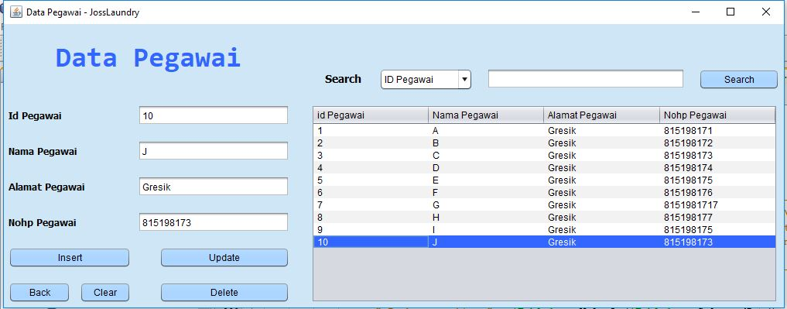

**Insert Data Pegawai Script :**

private void insertActionPerformed(java.awt.event.ActionEvent evt) {

try {

String sql = "INSERT INTO pegawai (id_pegawai, nama_pegawai, alamat_pegawai, nohp_pegawai) VALUES (?,?,?,?)";

PreparedStatement pst = conn.prepareStatement(sql);

pst.setString(1, txid.getText().trim());

pst.setString(2, txnama.getText().trim());

pst.setString(3, txalamat.getText().trim());

pst.setString(4, txnohp.getText().trim());

pst.execute();

clear();

tableload(jTable1);

JOptionPane.showMessageDialog(null, "Data Saved");

} catch (Exception ex) {

System.out.println(ex);

JOptionPane.showMessageDialog(null, ex.getMessage());

}

}

**Show Data Pegawai Script :**

private void tableload(JTable jt) {

DefaultTableModel dt = (DefaultTableModel) jt.getModel();

dt.setRowCount(0);

try {

ResultSet rset = db.getData("SELECT * FROM pegawai ORDER BY id_pegawai");

while(rset.next()){

Vector v = new Vector();

v.add(rset.getString(1));

v.add(rset.getString(2));

v.add(rset.getString(3));

v.add(rset.getString(4));

dt.addRow(v);

}

} catch (Exception ex) {

}

}

**Update pegawai Script :**

private void updateActionPerformed(java.awt.event.ActionEvent evt) {

try {

String sql = "UPDATE pegawai SET nama_pegawai = '"

+ txnama.getText() + "', alamat_pegawai = '"

+ txalamat.getText() + "', nohp_pegawai = "

+ txnohp.getText() + " WHERE id_pegawai = "

+ txid.getText();

PreparedStatement pst = conn.prepareStatement(sql);

pst.execute();

clear();

tableload(jTable1);

JOptionPane.showMessageDialog(null, "Data Updated");

} catch (Exception ex) {

JOptionPane.showMessageDialog(null, ex.getMessage());

}

}

**Delete Data Pegawai :**

private void deleteActionPerformed(java.awt.event.ActionEvent evt) {

db.putData("DELETE FROM pegawai WHERE id_pegawai = " + txid.getText());

clear();

tableload(jTable1);

JOptionPane.showMessageDialog(null, "Data Deleted");

}

**Search Data Pegawai :**

private void search1(JTable jt2) {

DefaultTableModel dt = (DefaultTableModel) jt2.getModel();

dt.setRowCount(0);

try {

ResultSet rset = db.getData("SELECT * FROM pegawai WHERE id_pegawai LIKE '%" + txsearch.getText() + "%'");

while(rset.next()){

Vector v = new Vector();

v.add(rset.getString(1));

v.add(rset.getString(2));

v.add(rset.getString(3));

v.add(rset.getString(4));

dt.addRow(v);

}

}catch (Exception ex) {

}

}